1300-874-444

Thank you for your purchase of the SC-SOL1 Solar GPS Tracking Device.
Your device comes tested and pre-configured, simply register your device with the included QR code or head to www.sitecomm.com.au/register and complete the registration form, please allow up to 2 hours during business hours for your registration to be processed.
Once Registration is completed you will get details sent to you via SMS.

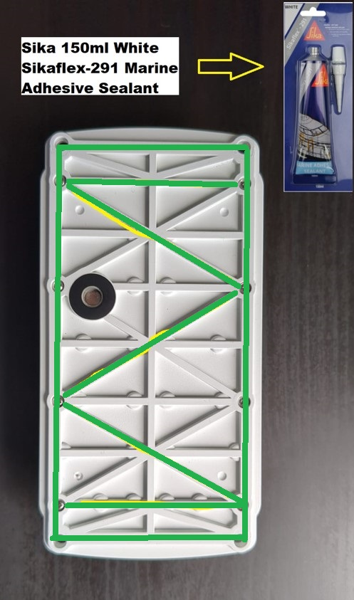
Installation Notes:
Installation of the solar device is simple using some Sikaflex 291 Marine Adhesive Sealant available from your local hardware store, or by using the mounting holes on the device.
Thoroughly clean the surface you wish to install the device on and apply Sikaflex 291 to the bottom of the Solar tracking device and mount to the roof of the vehicle. (i.e., Caravan, Horse Float etc.)
Allow the Sikaflex to dry for approximately 24 hours before driving/towing vehicle.

The SC-SOL1 tracking device is designed to charge from sunlight and maintain charge, if the device does not see the sunlight for some time the unit’s battery can go flat, included with the device is a magnetic charging cable that can charge the unit if needed, however if the unit sees sunlight on a regular basis, then charging is not required.
The Solar tracking device battery will last up to approximately 3 months on a full charge, and will only take 1-2 days of full sunlight to fully charge.
Battery level of the device can be monitored in the tracking platform.

Thank you again for your purchase if you have any questions, please contact our support at: support@sitecomm.com.au or 1300874444

